Pharma Contract Mining Assistant — Deployment Architecture Documentation

1. Technology Stack
Infrastructure & GCP Services
- Google Cloud Build —Docker image building
- Google Artifact Registry — Private Docker image storage
- Google Cloud Storage (GCS) — Contract document storage
- Google Compute Engine (VM) — Used (initial deployment)
- Firebase Hosting — Used for frontend hosting
- Google Cloud Load Balancer — Used for HTTPS termination
- Google-managed SSL Certificate — Used for HTTPS

2. Deployment Journey — Phase (VM-Based Architecture)
2.1 Overview
The initial deployment used a traditional VM-based architecture where the frontend and backend were deployed as separate services.
2.2 Architecture Diagram
User (Browser)
│
▼
Firebase Hosting (React Frontend)
│
│ API calls (HTTPS)
▼
Google Cloud Load Balancer
│ (SSL Termination — Google-managed certificate)
▼
Google Compute Engine VM (contract-mining-vm, us-central1-a)
├── Docker Container (FastAPI Backend
└── Local Storage (users.json, document previews)

2.3 Services Used and Why
Google Compute Engine VM
- Why used: Provided full control over the server environment
- Specification: VM in zone us-central1-a
- Role: Hosted the FastAPI backend inside a Docker container
- We Will be using the instance only during our project demonstration for that we are scheduling the runtime for the instance to save cost.
Docker on VM
- Why used: Isolated the application environment with all dependencies (LibreOffice, Python packages) packaged together
- Role: Ran the FastAPI backend as a containerized service
- Benefit: Consistent environment regardless of VM OS

Google Cloud Load Balancer
- Why used: VMs do not natively support HTTPS. The Load Balancer sat in front of the VM to handle SSL termination
- Role: Received HTTPS traffic on port 443, forwarded HTTP traffic to the VM on port 80/8080
- Benefit: Provided a stable public IP and HTTPS endpoint
Google-Managed SSL Certificate
- Why used: Required for HTTPS — encrypts traffic between users and the Load Balancer
- Role: Automatically provisioned and renewed by Google
- Benefit: No manual certificate management
- Our SSL certificate-ID: contract-mining-cert -> 34.8.253.140.nip.io
- No — Google-Managed SSL Certificate is completely FREE.

Feature | Cost
Certificate provisioning | $0
Certificate renewal (auto) | $0
Multiple domains on same cert | $0
- Google automatically provisions and renews it — no manual work, no cost ever.
Firebase Hosting
- Why used: Provided a fast, globally distributed CDN for serving the React frontend static files.
- Role: Hosted the compiled React build (HTML, CSS, JS)
- Benefit: Free tier, automatic HTTPS, global CDN, no server management
- Endpoint: Contract Mining Assistant
Resource | Free Limit | Your Usage
Storage | 10 GB | ~2-5 MB (React build)
Data transfer | 360 MB/day | Very low

Google Cloud Storage (GCS)
- Why used: Scalable object storage for contract PDF documents
- Bucket: pharm-contract-amendments
- Role: Stores uploaded contract files, accessible by backend for processing.

We scheduled the instance runtime to save the cost:

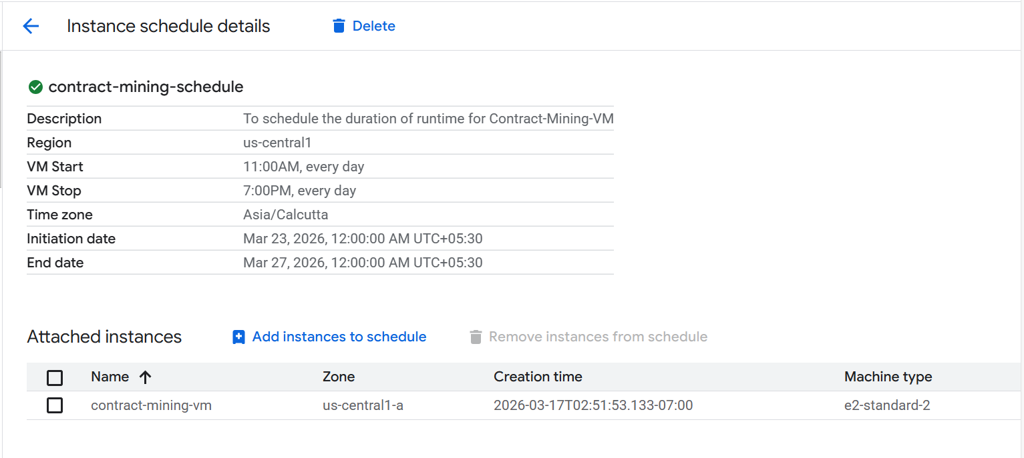
Load Balancer — contract-mining-url-map
- Type: Application Classic, External, HTTPS
- Purpose: The main Load Balancer that actually routes traffic to your VM
- Handles SSL termination using the Google-managed certificate
- Forwards decrypted traffic to the Instance Group → VM → Docker container
- This is the one connected to
contract-mining-backend-svc and contract-mining-ig

How They Worked Together
User types https://
│
▼
contract-mining-url-map (port 443)
│ SSL termination
▼
Instance Group (contract-mining-ig)
│
▼
VM (contract-mining-vm)
│
▼
Docker Container (FastAPI Backend)

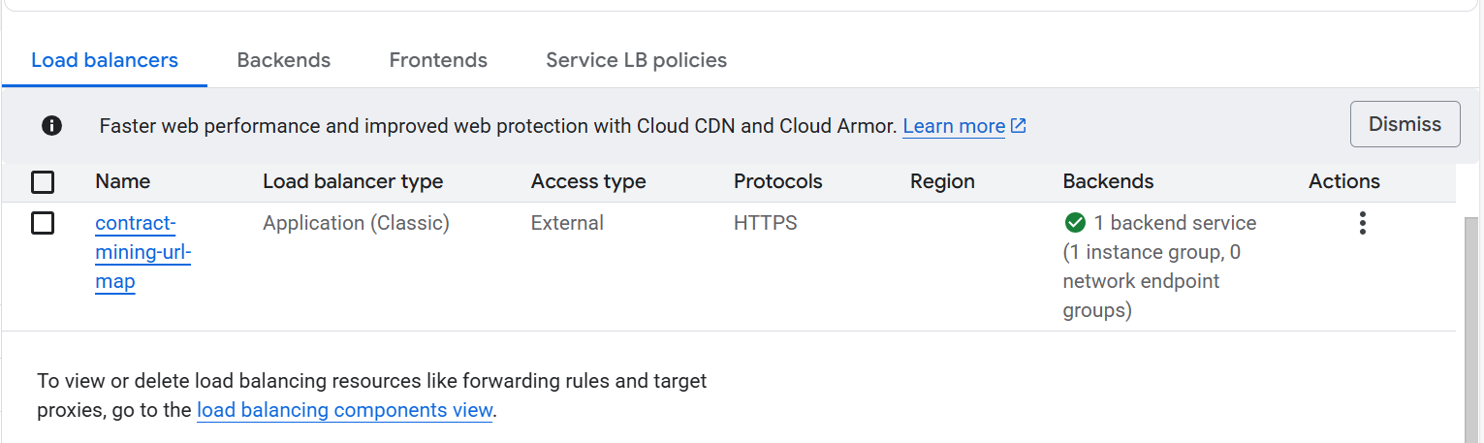

Artifact registry:
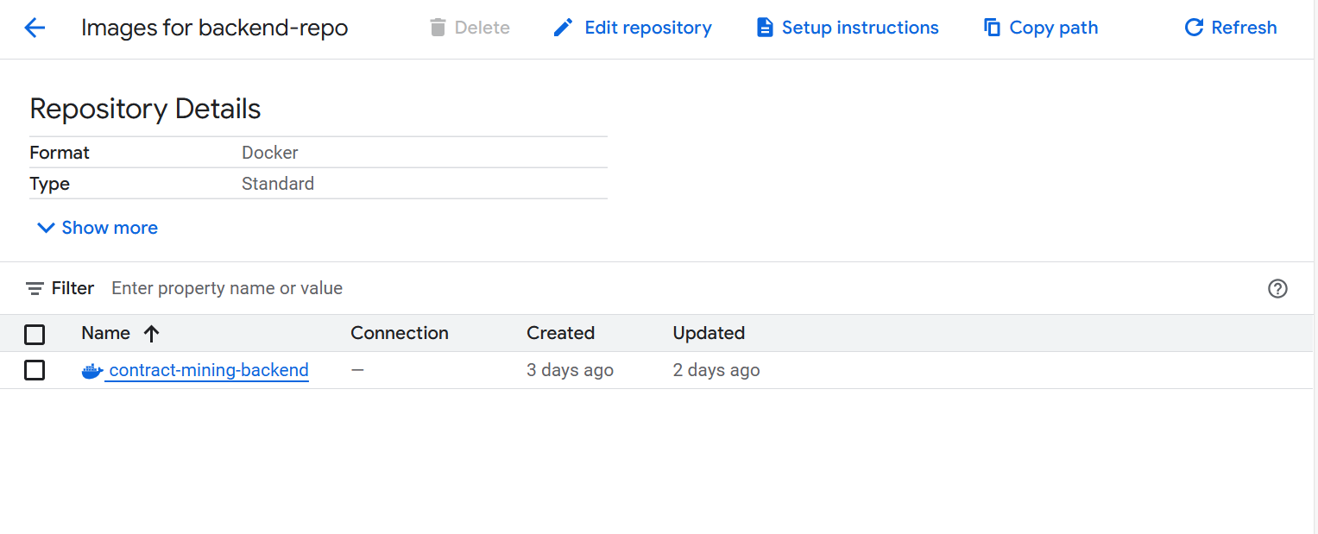
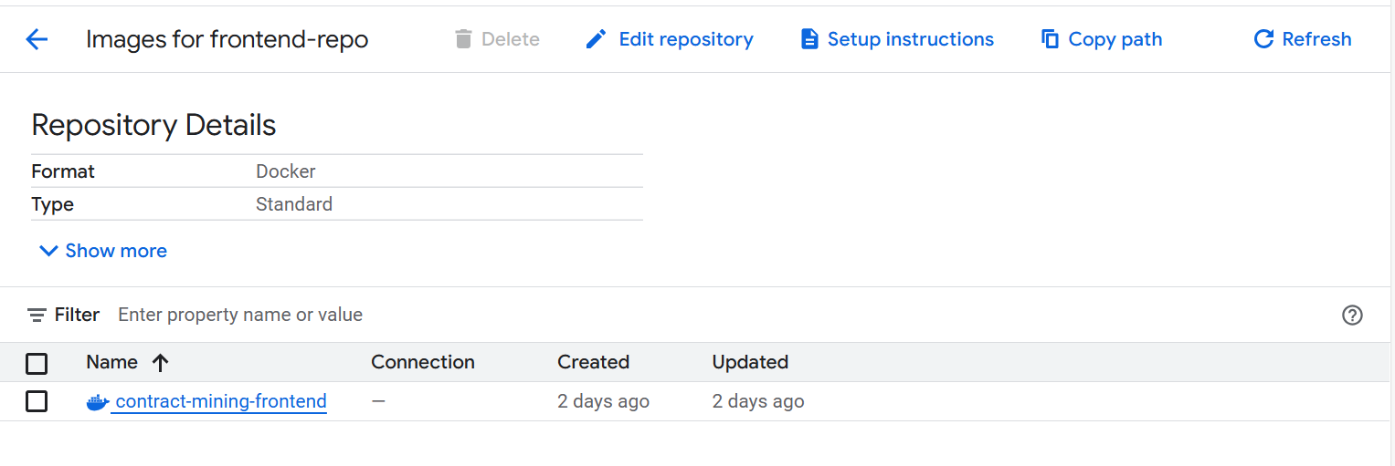

VPC:
Without Static IP — every time the Load Balancer restarts or gets updated, Google assigns a new random IP address. This means your app URL keeps changing and users can't reliably access it.
With Static IP — the IP
34.8.253.140
is permanently reserved for your Load Balancer. It never changes no matter what happens.
